ANOMALY DETECTION IN VIDEO
A BTP Report
B22MG01

by

Shanjana Pulagala
S20190010160

Virri Anusha
S20190010190

Dasari Charan Sai
S20190010038


INDIAN INSTITUTE OF INFORMATION TECHNOLOGY SRICITY
18th December 2022
Final Report

INDIAN INSTITUTE OF INFORMATION TECHNOLOGY SRICITY

CANDIDATE’S DECLARATION

I hereby certify that the work which is being presented in the BTP entitled “ANOMALY DETECTION IN VIDEO” in the partial fulfilment of the requirements for the award of the degree of B. Tech and submitted in the Indian Institute of Information Technology SriCity, is an authentic record of my own work carried out during the time period from January 2022 to December 2022 under the supervision of Dr. Mrinmoy Ghorai, Indian Institute of Information Technology SriCity, India.
The matter presented in this report has not been submitted by me for the award of any other degree of this or any other institute.
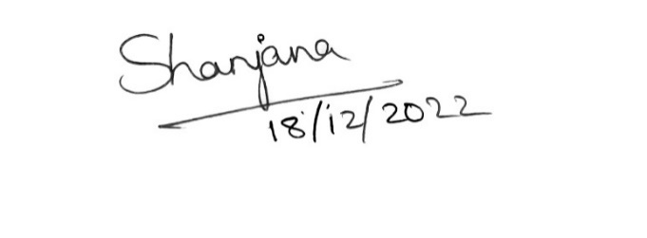

Shanjana Pulagala
− − − − − − − − − − − − − − − − − − − − − − − − − − − − − − − − − − − − − − − − − − − − − − − −
This is to certify that the above statement made by the candidate is correct to the best of my knowledge.

Signature of BTP Supervisor with date
Dr. Mrinmoy Ghorai


INDIAN INSTITUTE OF INFORMATION TECHNOLOGY SRICITY

CANDIDATE’S DECLARATION

I hereby certify that the work which is being presented in the BTP entitled “ANOMALY DETECTION IN VIDEO” in the partial fulfilment of the requirements for the award of the degree of B. Tech and submitted in the Indian Institute of Information Technology SriCity, is an authentic record of my own work carried out during the time period from January 2022 to December 2022 under the supervision of Dr. Mrinmoy Ghorai, Indian Institute of Information Technology SriCity, India.
The matter presented in this report has not been submitted by me for the award of any other degree of this or any other institute.


Virri Anusha
− − − − − − − − − − − − − − − − − − − − − − − − − − − − − − − − − − − − − − − − − − − − − − − −
This is to certify that the above statement made by the candidate is correct to the best of my knowledge.

Signature of BTP Supervisor with date
Dr. Mrinmoy Ghorai


INDIAN INSTITUTE OF INFORMATION TECHNOLOGY SRICITY

CANDIDATE’S DECLARATION

I hereby certify that the work which is being presented in the BTP entitled “ANOMALY DETECTION IN VIDEO” in the partial fulfilment of the requirements for the award of the degree of B. Tech and submitted in the Indian Institute of Information Technology SriCity, is an authentic record of my own work carried out during the time period from January 2022 to December 2022 under the supervision of Dr. Mrinmoy Ghorai, Indian Institute of Information Technology SriCity, India.
The matter presented in this report has not been submitted by me for the award of any other degree of this or any other institute.


Dasari Charan Sai
− − − − − − − − − − − − − − − − − − − − − − − − − − − − − − − − − − − − − − − − − − − − − − − −
This is to certify that the above statement made by the candidate is correct to the best of my knowledge.

Signature of BTP Supervisor with date
Dr. Mrinmoy Ghorai

ABSTRACT

Anomaly detection in videos is the process of identifying events that do not follow the expected pattern, which is a key problem in video surveillance. Most of the works proposed on anomaly detection in the video include reconstruction or frame prediction-based methods. Reconstruction techniques aim to reduce the reconstruction errors of training data; however, they are unable to guarantee small reconstruction errors for anomalous events. The idea behind future frame prediction techniques is that while regular events are predictable, abnormal ones are unexpected. However, since the prediction is not resistant to the noise in actual surveillance videos, the findings could drop off quickly.

So, here we have analyzed two methods one is Reconstruction-based anomaly detection and the other is Future Frame Prediction-based anomaly detection. In the case of reconstruction-based video anomaly detection first, we implemented it by using a Spatio-Temporal Autoencoder and obtained the results. But, by using the Autoencoder the loss between the ground truth and the reconstructed image frame could be high due to dimensionality reduction. Hence, we have then implemented the Future Frame Prediction method which includes the U-Net model and General Adversarial Networks (GAN) and then we analyzed the results. Later, we implemented the Reconstruction-based video anomaly detection using U-Net and Optical Flow as the produced outcome in the Reconstruction-based video anomaly detection using Autoencoder is not that satisfactory.

Finally, we have developed an approach that combines both reconstruction and frame prediction-based anomaly detection techniques parallelly. Experiments are conducted on the datasets (UCSD Ped1 and UCSD Ped2) to verify the efficiency of our method's sensitivity to abnormal events and resistance to uncertainty in regular events.

Contents

1. INTRODUCTION 7
2. LITERATURE SURVEY 8
3. PROBLEM STATEMENT 9
4. METHODOLOGY 10
5. RESULTS 15
6. CONCLUSION 21
7. LIST OF FIGURES 22
8. LIST OF TABLES 23
9. LIST OF ABBREVATIONS 24
10. REFERENCES 25
11. ACKNOWLEDGEMENTS 26
- INTRODUCTION

Anomaly can be any abnormal object and motion. The identification of occurrences that do not conform to predicted behavior is referred to as anomaly detection in videos. It is a critical activity because of its usage in video surveillance. However, it is highly difficult to detect anomalies since abnormal occurrences are unbounded in real-world applications, and gathering all types of abnormal events and tackling the problem with a classification approach is nearly impossible. Another issue is that the datasets are heavily biased towards the normal class due to the limited sample size of the abnormal ones, thus only the familiar class is accessible during training in most circumstances.
Many efforts have been put in to address these problems. Several techniques are based on the concept of reconstruction [2][3][4][7]. The main idea of reconstruction-based anomaly detection in these techniques is considering the image frame as an anomaly when the reconstruction error is high in that frame during the testing phase. These techniques basically consist of an Autoencoder which comprises encoder and decoder blocks. The encoder consists of Convolutional layers which obtain the self-representation from the input data and the decoder consists of deconvolutional layers which reconstruct them with feature encoding. Despite these models’ ability to recognize anomalous events and their tolerance to noise, depending on the complexity of the activity in the scene, these may yield more false alarms.
There are several frame prediction-based techniques [1][5][6] that use U-Net as well as General Adversarial Networks (GAN) models. The GAN model is used to generate high-quality frames. Instead of reconstructing training sets for anomaly detection, the GAN model identifies between normal and abnormal frames by comparing them to their predicted counterparts from the U-Net model. It has the potential to overcome the restrictions of reconstruction flaws, hence widening the gap between normal and anomalous frames. The following are the causes: For Reconstruction methods, for instance, a person running on a pedestrian street (abnormal occurrences); if a model is aware of the visual features of both backgrounds and humans during the training phase, it can readily reconstruct this anomalous scenario from the image input itself. However, for prediction methods, in order to anticipate what will happen next, the model must first gather prior knowledge. The model learns the motion properties of walking people from training datasets in the context of a pedestrian street. When stacked frames of a running person are given into the model, it's only able to predict a person walking, implying a huge disparity between the ground truth and predicted frames. This method is quite sensitive to noise, due to the Optical flow that is introduced as a motion constraint between the produced frame and the ground truth, which is sensitive to changes in light. The other reason is the fact that it uses the Peak Signal to Noise Ratio (PSNR) as a score to determine the degree of irregularity. PSNR, as a measure for estimating picture quality, doesn't always match human perception, as well as its value drops fast when images contain noise, causing more regular frames to be evaluated as abnormal.
Here, we have developed a method that adopts the advantages of both Reconstruction-based video anomaly detection as well as Future frame-prediction-based video anomaly detection. Future frame prediction increases the reconstruction mistakes of anomalous occurrences, making them more distinct. Meanwhile, reconstruction improves the predicted future image frames from normal occurrences, ensuring noise resilience. Thus, we have integrated these two methods by considering both blocks parallelly. The first block is the reconstruction model which obtains the loss values by taking the test inputs. Similarly, we obtain the loss values from the second block which is the frame prediction model. Then, we combine the loss values to achieve better accuracy.
- LITERATURE SURVEY

2.1. Reconstruction Methods:
Deep learning algorithms have seen a lot of success in a variety of industries. It also advances in anomaly detection by including deep characteristics in reconstruction. For example, prompted by Convolutional Neural Networks (CNN) great capacity to learn spatial information, a deep convolutional Autoencoder is trained to reconstruct an input sequence of frames. One of these deep approaches is Spatio-Temporal Autoencoder (Chong, Y. S., & Tay, Y. H., 2017), this method uses a combination of spatial feature extractor and temporal sequencer ConvLSTM. They constructed an end-to-end trainable model for video anomaly detection by including a convolutional feature extractor in both spatial and temporal space into the encoding-decoding framework. Despite the model's capacity to detect anomalous events and its tolerance to noise, it may create more false alarms than other approaches depending on the complexity of the activity in the scene.
The other deep approaches include Spatio-Temporal consistency-enhanced network (STCEN) (Hao, Y. et al., 2022) to detect anomalous data disturbances from both spatial and temporal perspectives. The spatiotemporal consistency between the produced future frame and its previous frames is measured using a 3D CNN-based discriminator. To extract motion and appearance fusion information from the input video clip, a well-designed 3D-2D U-shape structure is developed, which concentrates on extracting spatiotemporal high-level features and creating a logical future frame. Furthermore, for the video anomaly detection job, a resampling module is employed to increase the score gaps between normal and abnormal contents.
The Spatio-Temporal dissociation (Chang, Y. et, al., 2022) is the other deep learning algorithm-based reconstruction method that incorporates unique autoencoder architecture to split spatiotemporal information into two sub-modules in order to learn uniformity in both temporal and spatial feature spaces and create concise descriptions within normal occurrences.

2.2. Frame Prediction Methods:
Frame predictive methods attempt to predict the upcoming output frame based on numerous previous frames. Video frame prediction has recently grown in popularity because of its vast application in driverless cars, video understanding, and other fields. For example, a U-Net and General Adversarial Network (Xia, X. et al., 2022) models are used to generate a realistic future frame and to carry out adversarial training on the input image frames (Liu, W. et al., 2018). Also, Zhang, Q. et al., 2022 constructed an unsupervised anomaly detection approach for surveillance footage, based on frame prediction. Here, the high-quality frame is generated using a Generative Adversarial Network. The next future frame is predicted by two generators. To anticipate the global information, a non-local U-Net is presented as Generator 1. Generator 2 gathers additional connected prior frame characteristics as well as huge contour data. Anomalies are determined by comparing the expected frame with the ground truth.
As reconstruction approaches cannot guarantee a substantial reconstruction error for abnormalities, it is difficult to establish an adequate reconstruction error threshold to determine whether a hold unusual activity or not. Prediction approaches have the potential to widen the gap between normal and anomalous frames. However, adding noise-sensitive motion restrictions like optical flow to the framework reduces resilience compared to reconstruction alternatives. Accordingly, we have developed a method that combines the advantages of both Reconstruction-based video anomaly detection and Future Frame Prediction-based video anomaly detection.
- PROBLEM STATEMENT

With the fast expansion of video data, there is a growing demand not just for object recognition and behavior, but also for recognizing rare, fascinating instances of strange items or suspicious behavior in a vast body of conventional data. The detection of such anomalies in videos is critical for various applications from automated quality assurance to visual surveillance.
So, in order to detect the anomalies, we have analyzed the Reconstruction-based video anomaly detection method using Spatio-Temporal Autoencoder as well as the Reconstruction-based video anomaly detection method using U-Net & Optical flow and the Future Frame Prediction-based anomaly detection method. Then, we combined the Reconstruction and Future Frame Prediction methods in order to take advantage of both methodologies.

3.1. Contributions

Name | Contributions
Shanjana Pulagala | - Implementation of U-net model and Flownet and analysis of results in Future Frame Prediction-based video anomaly detection method.  - In the Reconstruction-based video anomaly detection method replaced the autoencoder model with U-net and Optical flow and analyzed the results.
Virri Anusha | - Implementation of Spatio-Temporal autoencoder model and analysis of results in Reconstruction-based video anomaly detection method.  - Trained and tested the Future frame Prediction model and calculated intensity loss, gradient loss (appearance loss), adversarial loss, optical flow loss (motion loss), and PSNR error.
Dasari Charan Sai | - Implementation of the Discriminator model and analysis of results in the Future frame Prediction-based video anomaly detection method.  - Combined the Reconstruction-based video anomaly detection model and Future frame Prediction-based video anomaly detection model.

Table 1: Contributions of each member

- METHODOLOGY

4.1. Reconstruction-based video anomaly detection method using Autoencoder

The approach consists of three main stages:

4.1.1. Pre-processing:
- Each frame is extracted from the raw videos and resized to 227 × 227.
- Images are converted to grayscale to reduce dimensionality.
- The processed images are normalized to zero mean and unit variance.

4.1.2. Feature Learning:
Proposes a convolutional Spatio-Temporal Autoencoder to learn the regular patterns in the training videos. It comprises two parts:
(i) ${Spatial autoencoder}^{[2][3]}$
(ii) ${Temporal encoder-decoder}^{[2][3]}$

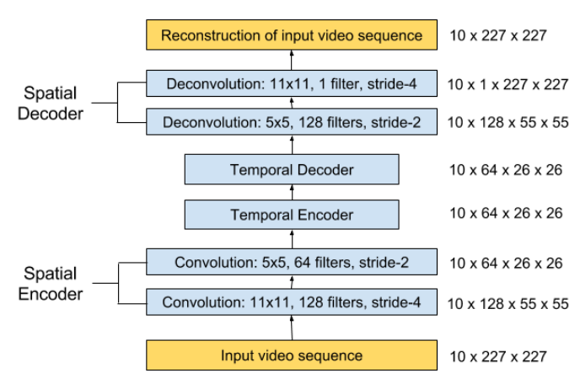

$${Figure 1:Spatio-temporal Autoencoder Architecture}^{[2]}$$

Figure 1 takes an input sequence of length T and outputs the reconstructed video sequence. Here, the spatial encoder takes input as one frame at a time. The encoder takes T = 10 frames as the number of frames in the input frames are multiple of 10. After processing, the encoded features of 10 frames are concatenated and given to the temporal encoder to undergo motion encoding. The decoder does the same job as the encoder but in a reverse way.

4.1.3. Regularity Score:
The reconstruction error is computed between the $t^{th}$ input frame 𝐼(𝑡) and the corresponding reconstructed frame $f_{w}(I(t))$ is:
$e(t) = {|| x(t)-f_{w}(I(t)) ||}_{2}$

Here, $f_{w}$ is the learned weights by the Spatio-Temporal model.
Next, we calculate abnormality score $S_{a}(t)$ by scaling between 0 and 1 and the mathematical equation is as follows:
$$S_{a}(t) = \frac{e(t) - {e(t)}_{min}}{{e(t)}_{max}}$$

We can obtain the regularity score $S_{r}\left(t\right)$can be calculated by subtracting abnormality score from 1, the mathematical equation is as follows:
$$S_{r}(t) = 1- S_{a}(t)$$

4.1.4. Anomaly Detection:
Each frame's reconstruction error decides whether the frame is categorized as anomalous. The threshold indicates how sensitive we want the detection system to be — for example, having a low threshold causes the system to become more sensitive to what is going on in the scene, resulting in more alarms being triggered. We compute the area under the receiver operating characteristic (ROC) curve using different error thresholds to determine the true positive and false positive rate (AUC). When the false positive rate equals the false negative rate, the equal error rate (EER) is produced.

The reconstruction method aims to minimize the reconstruction error encountered in training data. But in large datasets, the presence of a high number of abnormal occurrences makes it difficult for this method to accurately reconstruct such image frames when compared to less abnormal frames. Also, the potential of Autoencoders to reconstruct the original input frame to its most identical one is only possible to some extent as the loss between the ground truth and reconstructed frame is more due to dimensionality reduction. Hence, we had chosen Future Frame Prediction method for Anomaly Detection in Video and its combination with Reconstruction to have the best of both worlds.

4.2. Future Frame Prediction-based video anomaly detection method

For anomaly identification, it is more natural to predict future video frames based on recent video frames and compare the prediction to its ground truth. As a result, ${video prediction}^{[1]}$ is suggested to detect anomalies. Thus, it is proposed to incorporate an optical flow restriction into the objective function to ensure motion consistency for normal events in the training set, which improves performance for anomaly detection even more.

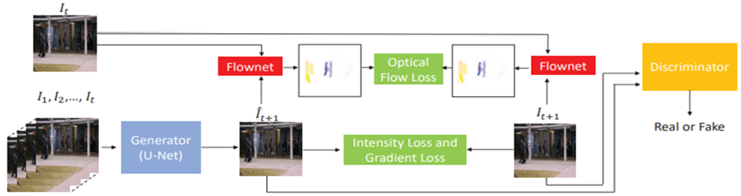

$${Figure 2:Pipeline of Video frame Prediction}^{[1]}$$

Here, we take a video of t consecutive frames $I_{1}, I_{2}, I_{3}, I_{4},......., I_{t}, I_{t+1}$and sequentially stack them and use them to predict future frame $I_{t+1}$. We are considering ${\hat{I}}_{t+1}$ the predicted frame. To get ${\hat{I}}_{t+1}$ closer to $I_{t+1}$, we reduce their distance in terms of both intensity and gradient. We enforce the optical flow between $I_{t+1}$ and $I_{t}$ and that between ${\hat{I}}_{t+1}$ and $I_{t}$ to be near in order to maintain temporal coherence between surrounding frames. Finally, whether a future frame is normal or abnormal is determined by the difference between its prediction and itself. Figure 2 depicts the framework's network architecture.

4.2.1. U-Net:
- This adds a shortcut between the high-level layer and low-level layer with the same resolution, resulting in symmetry.
- Figure 3 depicts the architecture of ${U-Net}^{[1][5]}$ which is symmetric consisting of two major parts:
  - The left part is called the contracting path, which is constituted by the general convolutional process.
  - The right part is an expansive path, which is constituted by transposed 2D convolutional layers.
- The kernel sizes of all convolution and deconvolution are set to 3 × 3 and that of max pooling layers are set to 2 × 2.
- In order to suppress the encountered gradient vanishing and information imbalance issues, in each layer of the future frame generation, U-Net is employed.
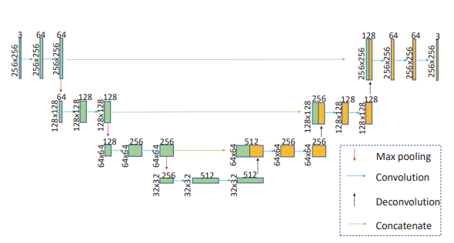

$${Figure 3:U-Net Architecture}^{[1]}$$

4.2.2. General Adversarial Networks (GAN):
- ${Generative Adversarial Networks}^{\left[1\right][6]}$, commonly referred to as GAN, contains a discriminative network D and a generator network G as shown in figure 4.
- G learns to generate frames that are hard to be classified by D.
- U-Net based prediction networks are treated as G while D aims to discriminate the frames generated by G.
- The discriminator model takes an example from the domain as input (real or generated) and predicts a binary class label of real or fake (generated).
- We obtain loss functions by training D and G respectively.
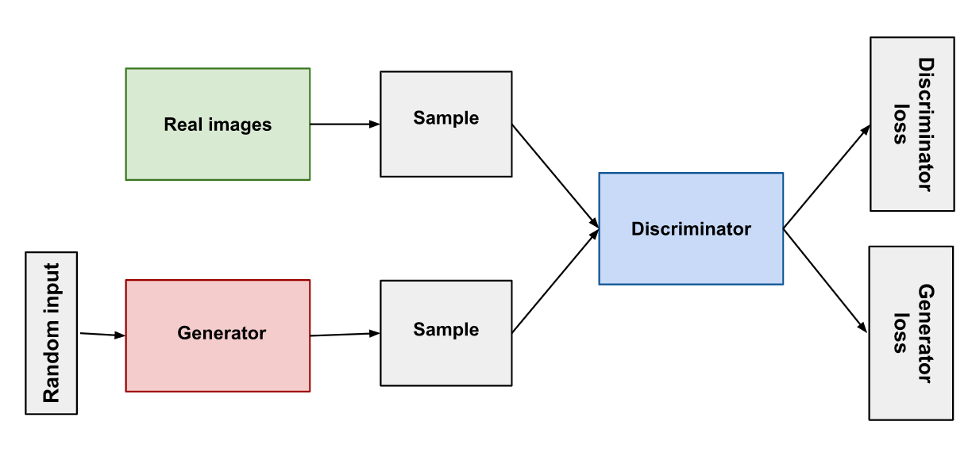
$${Figure 4:GAN architecture}^{[8]}$$
4.2.3. Gradient Loss:
The gradient difference is employed to obtain the prediction close to the ground truth.
The mathematical formula for gradient loss is as follows:

$$L_{gd}(\hat{I},I) = \sum_{i,j}^{.}{{|||{\hat{I}}_{i,j}-{\hat{I}}_{i-1,j}|-|I_{i,j}-I_{i-1,j}|||}_{1}+{|||{\hat{I}}_{i,j}-{\hat{I}}_{i,j-1}|-|I_{i,j}-I_{i,j-1}|||}_{1}}$$

4.2.4. Constraint on Motion:
For evaluating normal events, coherence of motion plays a key role, and hence the difference between the optical flow of prediction frames and ground truth aka., Temporal Loss is considered.
The optical flow loss equation is as follows:

$$L_{op}({{\hat{I}}_{t+1}}_{.}, I_{t+1}, I_{t}) ={ {||f({{\hat{I}}_{t+1}}_{.},I_{t})-f( I_{t+1}, I_{t})||}_{1}}_{.}$$

4.2.5. Anomaly Detection on Testing Data:
Assuming that regular events can be accurately anticipated. As a result, we can anticipate anomalies using the difference between the predicted frame $\hat{I}$ and its ground truth $I$.
The Peak Signal to Noise Ratio (PSNR) is the best way for quality assessment on an image than that of the MSE (Mean Squared Error).
The Mathematical formula for PSNR is as follows:

$PSNR(I, \hat{I}) = 10{\log_{10}(\frac{{[\max_{\hat{I}}]}^{2}}{\frac{1}{N}(\sum_{i=0}^{N}{.}{(I_{i}- {\hat{I}}_{i})}^{2})})}_{.}^{.}$

By normalizing PSNR to the range of [0,1] we can obtain regularity score by the following equation:

$$S(t) = \frac{PSNR(I_{t},{\hat{I}}_{t}) - \min_{t}PSNR(I_{t},{\hat{I}}_{t})}{\max_{t}PSNR(I_{t},{\hat{I}}_{t}) - \min_{t}PSNR(I_{t},{\hat{I}}_{t})}$$

So, based on the Regularity score we determine whether a frame is normal or abnormal. If the regularity score is high then the frame is normal otherwise abnormal.

4.3. Reconstruction-based Video anomaly detection using U-Net and Optical Flow

We have previously mentioned about Reconstruction-based video anomaly detection method using Autoencoder which basically includes Encoder and Decoder block with convolutional and deconvolutional layers. As the autoencoder is not that efficient to detect the anomaly because of its disadvantages of dimensionality reduction for input images that cause high reconstruction loss. We have replaced the autoencoder with U-Net and optical flow to obtain better accurate results.

4.4. Combination of Reconstruction and Future Frame Prediction models

The combination is carried out parallelly. The steps followed are:
- First, Reconstruction and Frame Prediction models are trained separately.
- Both the models are tested and respective PSNR loss values are obtained.
- Then, the PSNR values of both models are combined to achieve the accuracy of the combination.

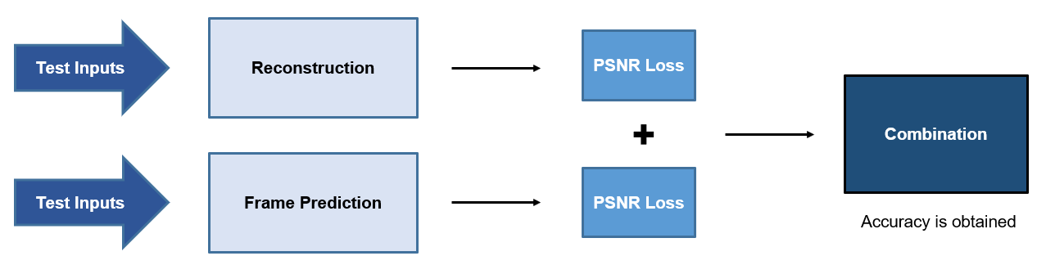

Figure 5: Combination of Reconstruction and Frame Prediction models

- RESULTS

5.1. Datasets

Dataset Link: http://101.32.75.151:8181/dataset/

S. No | Dataset | Elements in Dataset
1 | UCSD-  UCSD Pedestrian 1 (Ped1) | [Abnormal cases are about vehicles such as bicycles and cars]  34 training videos & 36 testing videos with 40 rare events.
2 | UCSD-  UCSD Pedestrian 2 (Ped2) | [Abnormal cases are about vehicles such as bicycles and cars]  16 training videos & 12 testing videos with 12 abnormal events.

Table 2: Information about Datasets

We have used Ped1 and Ped2 datasets to obtain the results for all the models.

5.2. Reconstruction-based video anomaly detection using Autoencoder

We tested the Reconstruction-based method using autoencoder using both Ped1 and Ped2 datasets.
Then, we plotted the Regularity score curves for the Ped2 dataset for all the test datasets.
Here, are two samples showing the Regularity Score curves.

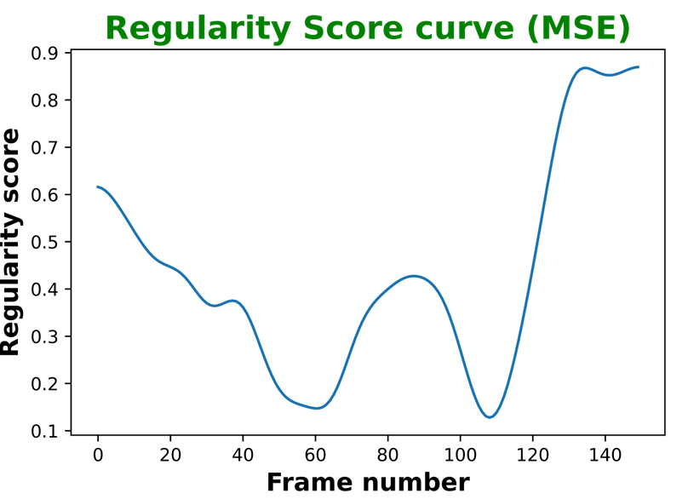
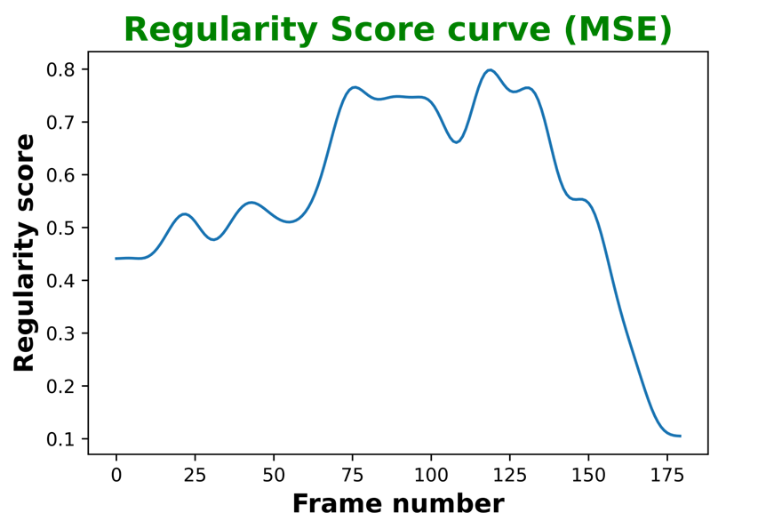
Test Sample-1: Test Sample-2:

At last, we obtained the accuracy of Ped2 and Ped1 datasets for the Reconstruction-based method using Autoencoder.
The ROC curves for Ped2 and Ped1 datasets are as follows:

Dataset: Ped2 Dataset: Ped1
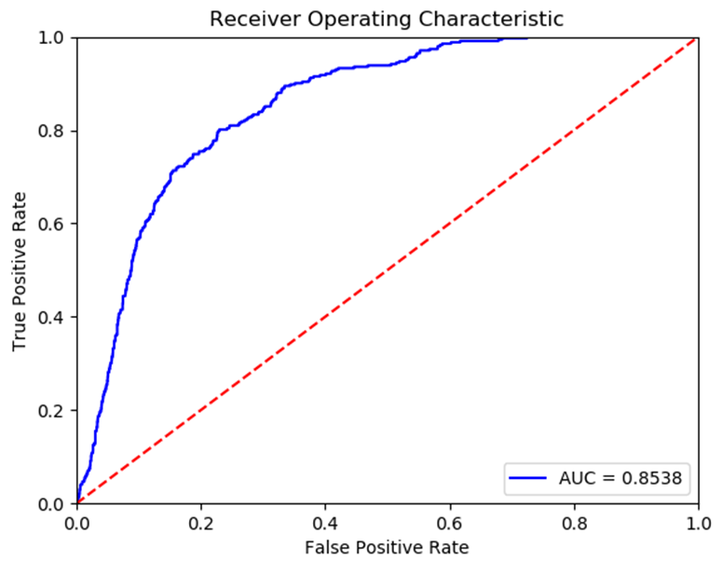

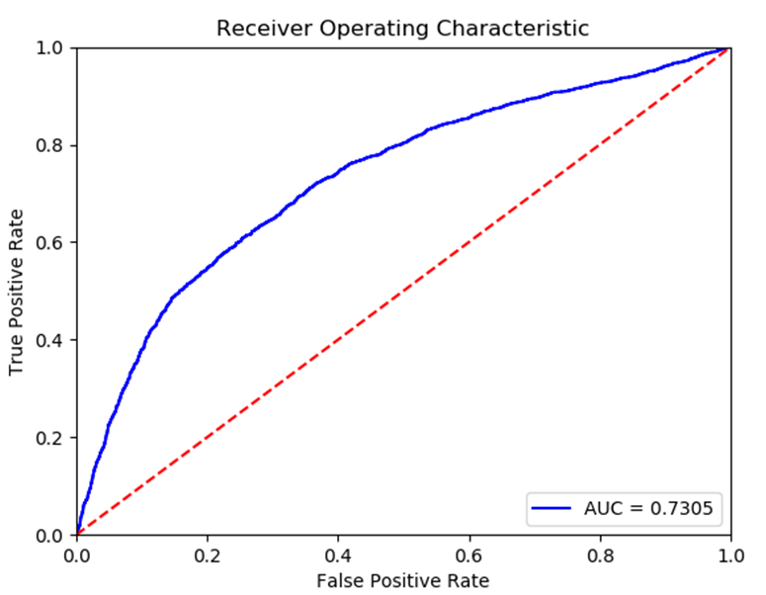

Optimal Accuracy: 85.38% Optimal Accuracy: 73.05%

After plotting ROC curves for the test dataset, the accuracy obtained for the Ped2 dataset is 85.38% and for Ped1 dataset is 73.05%.

5.3. Future Frame prediction-based video anomaly detection
We have trained the Future Frame prediction-based method using both Ped2 and Ped1 datasets using around 30,000 epochs and obtained the Train PSNR curve.
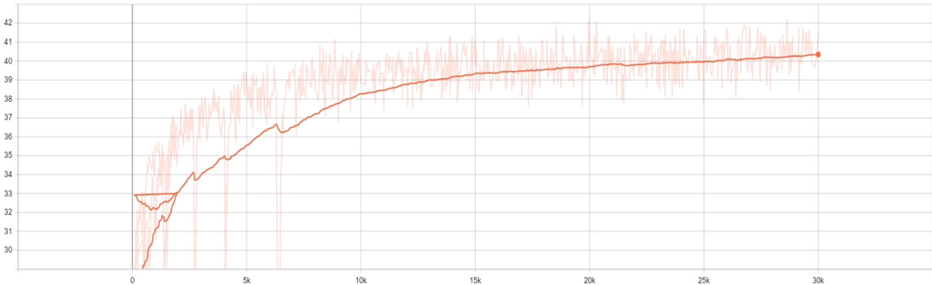
.

PSNR

Number of epochs

Figure 6: Train PSNR curve

We then tested the model for Ped2 and Ped1 datasets.
Then, we plotted the Regularity score curves for the Ped2 dataset for all the test datasets.
Here, are two samples showing the Regularity Score curves.

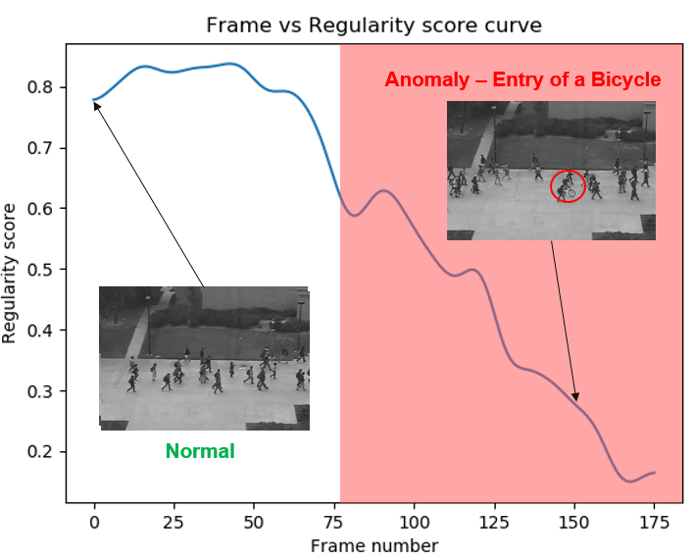
Test Sample-1: Test Sample-2:
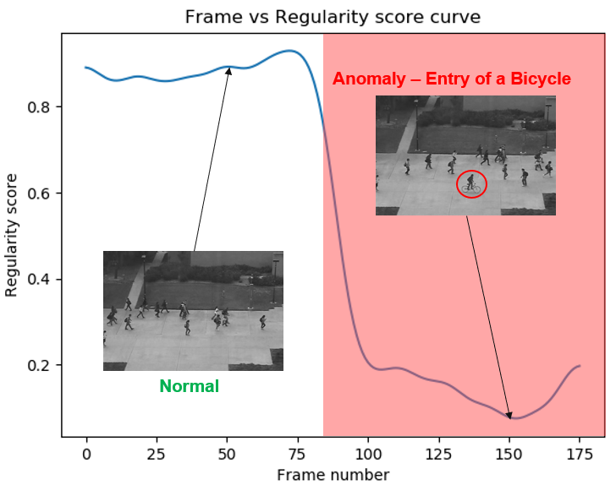

Here, in test sample-1 we can observe that the regularity score is high for frames 1 to 75 and then the regularity started decreasing. If the regularity score is high then the frame is considered normal. So, in this case, 1st image frame has normal activity i.e., all the pedestrians are walking which has high regularity score. Then the 150th frame has an entry of bicycle, which is an anomaly so for that frame the regularity score is less. Similarly, for test sample- 2, the regularity score is high for frames 1 to 90 and then started decreasing.

At last, we obtained the accuracy of Ped1 and Ped2 datasets for the Future Frame Prediction-based method.
The ROC curves for Ped2 and Ped1 datasets are as follows:

Dataset: Ped2 Dataset: Ped1
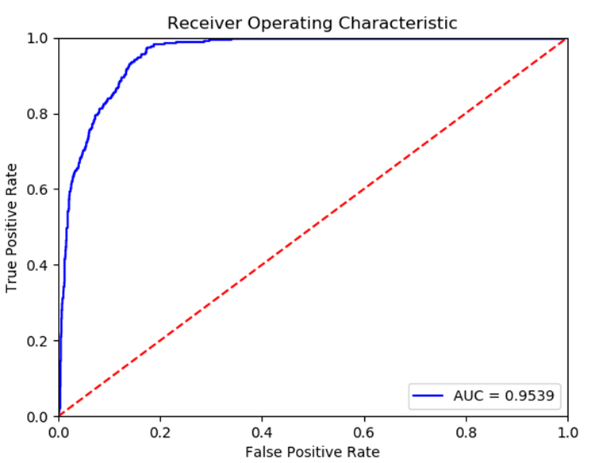
Optimal Accuracy: 95.39% Optimal Accuracy: 82.30%
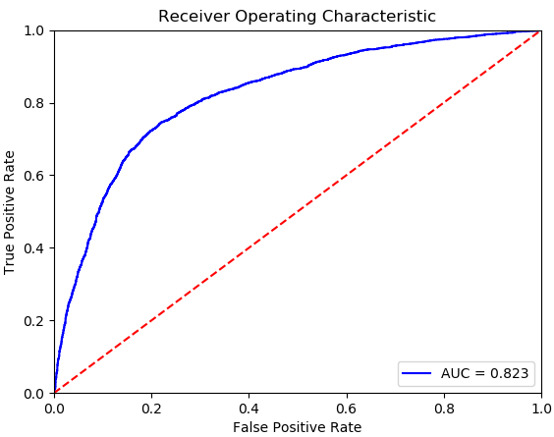

After plotting ROC curves for the test dataset, the accuracy obtained for the Ped2 dataset is 95.39% and for Ped1 dataset is 82.30%.

5.4. Reconstruction-based Video Anomaly Detection using U-Net and Optical Flow

We tested the Reconstruction-based method using U-Net and Optical flow using both Ped2 and Ped1 datasets. Then, we obtained the accuracy of Ped2 and Ped1 datasets for the Reconstruction-based method using U-Net and Optical Flow.
The ROC curves for Ped2 and Ped1 datasets are as follows:

Dataset: Ped2 Dataset: Ped1
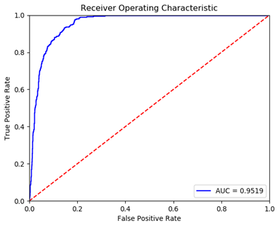
Optimal Accuracy: 95.19% Optimal Accuracy: 82.29%
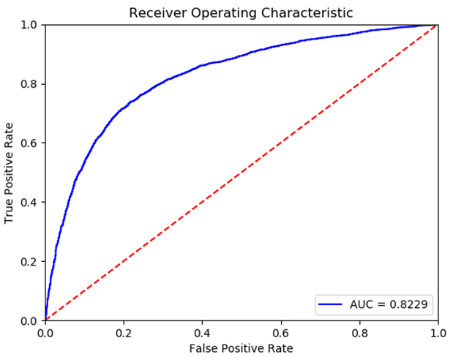

After plotting ROC curves for the test dataset, the accuracy obtained for the Ped2 dataset is 95.19% and for Ped1 dataset is 82.29%.

5.5. Combination of Reconstruction using Autoencoder with Frame Prediction

We tested the model for both Ped2 and Ped1 datasets and obtained accuracy using ROC curves.

Dataset: Ped2 Dataset: Ped1
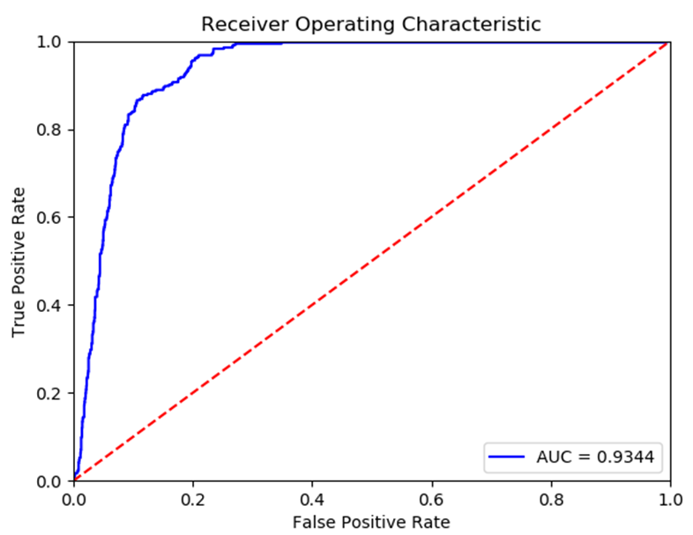
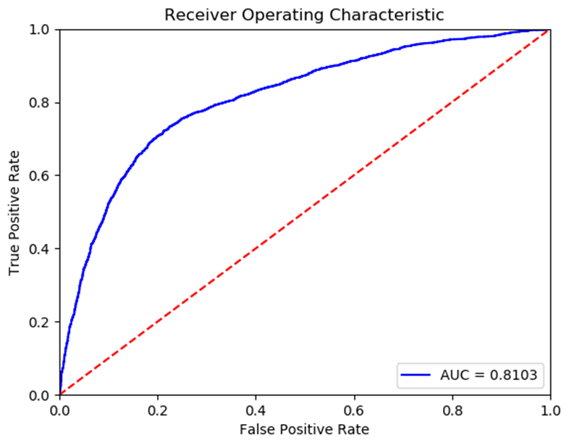
Optimal Accuracy: 93.44% Optimal Accuracy: 81.03%

After plotting ROC curves for the test dataset, the accuracy obtained for the Ped2 dataset is 95.19% and for Ped1 dataset is 82.19%.

5.6. Combination of Reconstruction using U-Net & Optical Flow with Frame Prediction

We tested the model for both Ped2 and Ped1 datasets and obtained accuracy using ROC curves.

Dataset: Ped2 Dataset: Ped1
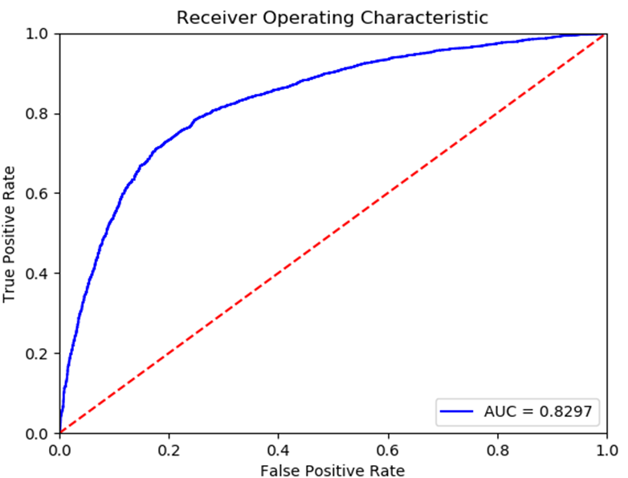
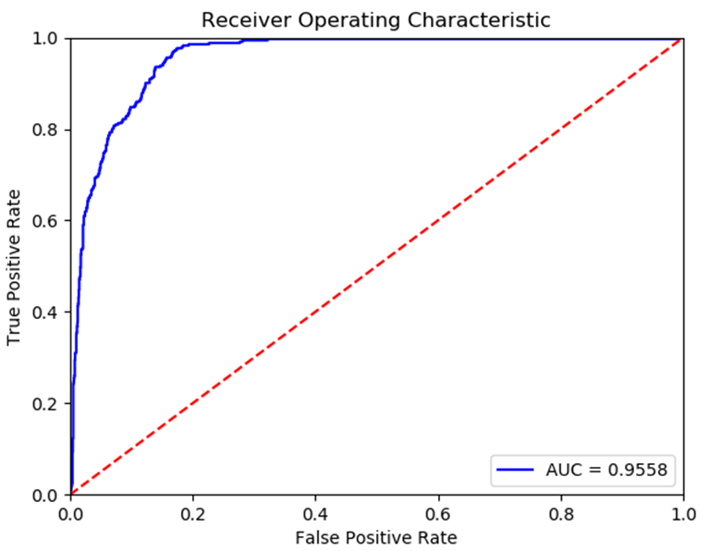
Optimal Accuracy: 95.58% Optimal Accuracy: 82.97%

After plotting ROC curves for the test dataset, the accuracy obtained for the Ped2 dataset is 95.58% and for Ped1 dataset is 82.97%.

S. No | MODEL | DATASET
 |  | Ped2  (in %) | Ped1  (in %)
1 | Reconstruction using Autoencoder | 85.38 | 73.05
2 | Frame Prediction | 95.39 | 82.30
3 | Reconstruction using U-Net and Optical Flow | 95.19 | 82.29
4 | Combination of Reconstruction using Autoencoder and Frame Prediction | 93.44 | 81.03
5 | Combination of Reconstruction using U-Net & Optical Flow and Frame Prediction | 95.58 | 82.97

Table 3: Comparison of performance of approaches on Ped2 and Ped1 datasets

So, here is the table showing the overall accuracy of all the models and comparison between them. We can say that the Combination of Reconstruction using U-Net and Optical Flow and Frame Prediction has better accuracy values when compared with other models.

- CONCLUSION

Future Frame Prediction-based video anomaly detection and Reconstruction-based video anomaly detection have their own advantages and disadvantages. So, we have analyzed the results of Reconstruction-based video anomaly detection using Spatio-Temporal Autoencoder. This method has not shown satisfactory results because of the inability of the Autoencoder to give a similar reconstructed frame as the original one, as well as their high reconstruction loss in the training phase due to dimensionality reduction. Therefore, we have analyzed the results of Future Frame Prediction-based video anomaly detection which uses U-Net and GAN models. Because of, the inefficiency of the Reconstruction-based method using Autoencoder we have replaced the Autoencoder with U-Net an optical flow to attain better accurate results. Then, we developed a combination model of Reconstruction and Prediction-based methods which takes the PSNR outputs from them and combine them. Experimentation of all these models on Ped1 and Ped2 datasets shows the Combination of Reconstruction using U-Net & Optical Flow and Frame Prediction outperforms the other models.

6.1. Future Work

In the Future Frame Prediction-based video anomaly detection, the U-Net model used to generate a future frame has definitely provided better results. But, during the up-sampling in the expanding path, the spatial information recreated is imprecise. To address this issue, the U-Net employs skip connections that integrate spatial information from the down-sampling path with spatial information from the up-sampling path. However, because feature representation is weak in the earliest layers, this results in numerous redundant low-level feature extractions. So, at the skip connections, we may include an attention module that actively suppresses activations in unnecessary areas, limiting the number of features brought across.
Therefore, we can attain better accurate results by combing the Reconstruction and Future Frame Prediction-based methods. Also, while combining the PSNR values of the Reconstruction a Frame Prediction model we can achieve much better results by a weighted average of both values where the weights are determined by the PSNR value.

- LIST OF FIGURES

1. Spatio-temporal Autoencoder Architecture 10
2. Pipeline of Video frame Prediction 12
3. U-Net Architecture 13
4. GAN Architecture 13
5. Combination of Reconstruction and Frame Prediction models 15
6. Train PSNR curves 17

- LIST OF TABLES

1. Contributions of each member 9
2. Information about Datasets 15
3. Comparison of performance of approaches on Ped2 and Ped1 datasets 20

- LIST OF ABBREVATIONS

GAN general adversarial network.
PSNR peak signal to noise ratio.
CNN convolutional neural network.
ROC receiver operating characteristic.
AUC area under curve.
EER equal error rate.
UCSD Ped1 University of California San Diego Pedestrian 1.
UCSD Ped2 University of California San Diego Pedestrian 2.

- REFERENCES

[1] Liu, W., Luo, W., Lian, D., & Gao, S. (2018). Future frame prediction for anomaly detection–a new baseline. In Proceedings of the IEEE conference on computer vision and pattern recognition (pp. 6536-6545).
[2] Chong, Y. S., & Tay, Y. H. (2017, June). Abnormal event detection in videos using spatiotemporal autoencoder. In International symposium on neural networks (pp. 189-196). Springer, Cham.
[3] Hao, Y., Li, J., Wang, N., Wang, X., & Gao, X. (2022). Spatiotemporal consistency-enhanced network for video anomaly detection. Pattern Recognition, 121, 108232.
[4] Chang, Y., Tu, Z., Xie, W., Luo, B., Zhang, S., Sui, H., & Yuan, J. (2022). Video anomaly detection with spatio-temporal dissociation. Pattern Recognition, 122, 108213.
[5] Zhang, Q., Feng, G., & Wu, H. (2022). Surveillance video anomaly detection via non-local U-Net frame prediction. Multimedia Tools and Applications, 1-16.
[6] Xia, X., Pan, X., Li, N., He, X., Ma, L., Zhang, X., & Ding, N. (2022). GAN-based Anomaly Detection: A Review. Neurocomputing.
[7] Singh, P. S., & Karthikeyan, S. (2022). Salient object detection in hyperspectral images using deep background reconstruction based anomaly detection. Remote Sensing Letters, 13(2), 184-195.
[8] BARIŞKAN, M. A., Orman, Z., & ŞAMLI, R. (2020). Common generative adversarial network types and practical applications. Avrupa Bilim ve Teknoloji Dergisi, 585-590.

- ACKNOWLEDGEMENTS

In the accomplishment of completion of our project on “ANOMALY DETECTION IN VIDEO” we would like to convey our special gratitude to Dr. Mrinmoy Ghorai, of Computer Science and Engineering department of Indian Institute of Information Technology SriCity.

Your insightful advice and suggestions aided us in various stages of the project's completion. We shall be immensely thankful to you in this regard.


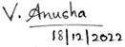


Shanjana Pulagala Virri Anusha Dasari Charan Sai

